Lab 7

1a. Report descriptive statistics for all fields in the table below. Use two significant digits for the rate of natural increase and one decimal for all others. (3 points)

1b. For each field, examine the distribution and indicate which (if any) countries are outliers. (2 points)

|  |  |  |  |  |  |  |  |
| --- | --- | --- | --- | --- | --- | --- | --- |
|  | Area (km2) | Population (# of people) | Birth Rate (per 1,000) | Death Rate (per 1,000) | Growth Rate (%) | Population Density (people/k m2) | Rate of Natural Increase |
| Minimum | 2.0 | 29973.0 | 8.2 | 5.4 | -0.9 | 3.0 | -638.00 |
| Maximum | 643427.0 | 82369548.0 | 15.2 | 15.9 | 2.0 | 16398.0 | 978.00 |
| Range | 643425.0 | 82339575.0 | 7.0 | 10.5 | 2.8 | 16395.0 | 1616.00 |
| Sum | 6043791.2 | 588843085.0 | 435.7 | 427.9 | 7.1 | 22684.1 | 782.00 |
| Mean | 140553.3 | 13694025.2 | 10.1 | 10.0 | 0.2 | 527.5 | 18.19 |
| Standard Deviation | 172108.8 | 20358971.7 | 1.5 | 2.3 | 0.6 | 2515.0 | 327.86 |

Question 2 –Provide screenshots of each classification type. For each classification type, explain how it is either appropriate or inappropriate for classifying population data. Remember to only use 5 to 6 classes for each classification scheme. (5 points total)

Std Dev: Std dev one does not separate data into enough classes, it’s data does not fall evenly into enough classes, and therefore all countries are categorized into the same class, making much of the data useless.

Quantile: While this method more adequately separates data into classes and shows change over country with more contrast, it also does not distribute it completely evenly which leads to some areas having the same color and not being able to be accurately contrasted.

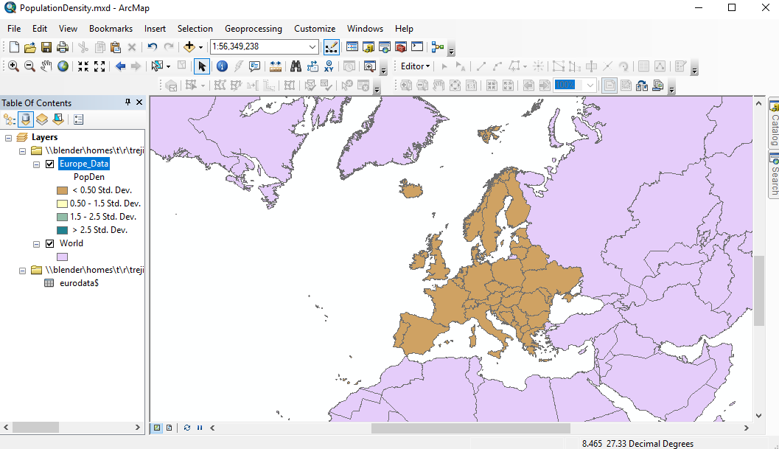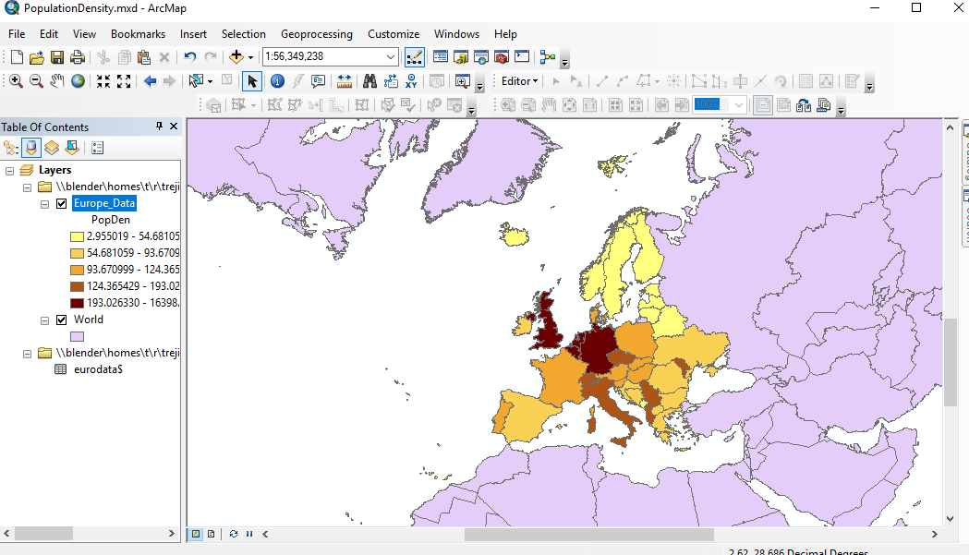

Jenks: the Jenks classification helps to better show the subtly gradient between countries. It classifies in more equal distribution across the classes and makes it easier to identify different amounts.

Equal interval: this was one of the worst classification methods presented. It did not evenly distribute the data throughout the classes, and you can tell by the almost illegibility of the map. All countries are in the same class almost, and you cannot tell the values of each apart or use them for any meaningful analysis

Defined Interval: the definite interval had many of the same problems as the equal interval. It separates many of the countries into the same classes due to it not distributing the data evenly into separate classes leading to uniformity in class and yielding analysis almost useless.

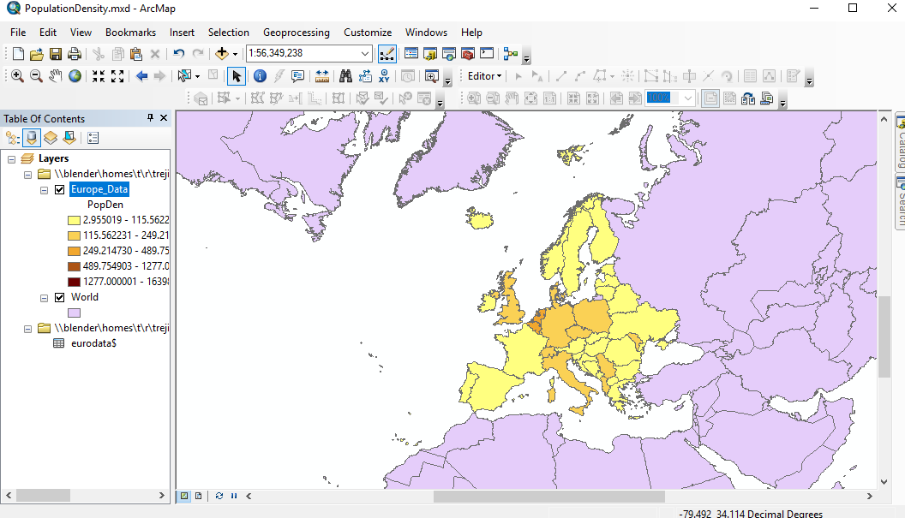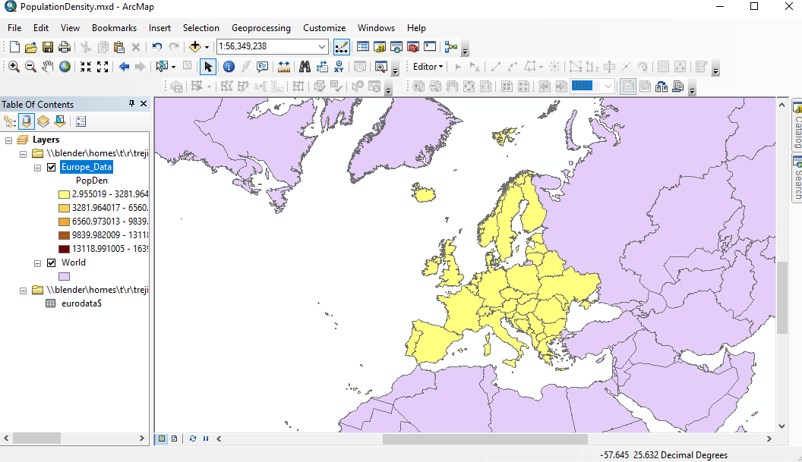

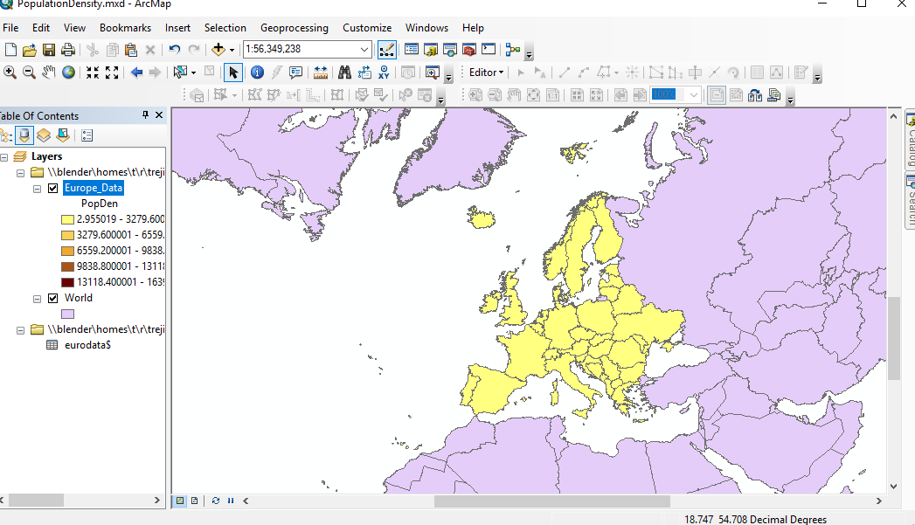

Question 4 – Export a PDF version of your finished map with the name Map1_NatInc.pdf. Describe the classification scheme you used for mapping the rate of natural increase data and justify your decision. Be sure that your map has all of the required map elements and a clear and informative legend. (15 points)

I chose to classify my map by Standard Deviations. I used this scheme because it most clearly exemplified the classes and broke up the data into 5 relatively even classes, due to the data being more evenly spread than the previous map. In contrast, the Equal Interval had the last class almost empty save for outliers. The standard deviation method more equally grouped data into classes compared to this one.

Question 5 – Export a PDF version of your finished map with the name Map1_BirthDeath.pdf. Describe the classification scheme you used for mapping both datasets and justify your decision. Be sure that your map has all of the required map elements and a clear and informative legend. (15 points)

For birth and death I decided the best scheme would be 5 equal divisions due to the fact that the classes needed to be in the same locations to be comparable. Because the maps needed to be comparable, many of the relative or calculation based classification methods would not work, yielding different classes for the two sets of data and rendering any comparison useless. Due to this, each class containing 20% seemed to be the best method for me.